# Submission 1- Paper/Project Proposal

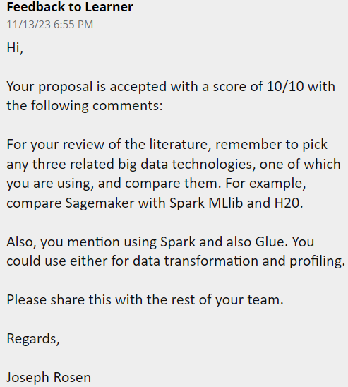

# Submission 2-Project/Paper Draft

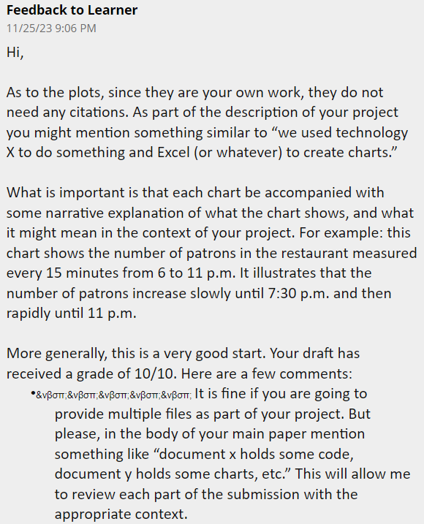

Feedback to Learner

11/25/23 9:06 PM

Hi,

As to the plots, since they are your own work, they do not need any citations. As part of the description of your project you might mention something similar to “we used technology X to do something and Excel (or whatever) to create charts.”

What is important is that each chart be accompanied with some narrative explanation of what the chart shows, and what it might mean in the context of your project. For example: this chart shows the number of patrons in the restaurant measured every 15 minutes from 6 to 11 p.m. It illustrates that the number of patrons increase slowly until 7:30 p.m. and then rapidly until 11 p.m.

More generally, this is a very good start. Your draft has received a grade of 10/10. Here are a few comments:

•&νβσπ;&νβσπ;&νβσπ;&νβσπ;&νβσπ; It is fine if you are going to provide multiple files as part of your project. But please, in the body of your main paper mention something like “document x holds some code, document y holds some charts, etc.” This will allow me to review each part of the submission with the appropriate context.

Remember to share this with the rest of the team.

Regards,

Joseph Rosen